**1a. What is the hostname and IP address of Google’s authoritative name server?**

Hostname: ns1.google.com

IP: 216.239.32.10

**1b. Suppose that there is a client C and a local name server L. Client C wants to lookup the address for www.google.com. List the sequence of DNS queries and responses that must happen. Assume that all name servers already knows the address of the authoritative root server. Assume that all name servers initially have an empty cache. You may assume either a recursive or an iterative lookup.**

L contacts the root asking for the IP of www.google.com. The root server suggests that L communicate with the authoritative name server for com at 192.5.6.30. So, L contacts that IP asking for the IP of www.google.com. The com authoritative name server suggests that L communicate with the authoritative name server for google.com at 216.239.32.10. So, L contacts that IP asking for the IP of www.google.com. The google.com authoritative name server says that it is the authoritative name server for www.google.com and provides L with the IP it was looking for – 66.102.7.10.

**1c. Following the previous query, client C wants to lookup the address for mail.google.com. List the sequence of queries and responses. Assume that results from the previous query are cached with long TTLs.**

Since these addresses are cached with a TT, when C wants to lookup the address for mail.google.com it will talk directly to google.com instead of beginning at the root. This saves a ton of time! So it will contact google.com at 216.239.32.10 asking for the IP of mail.google.com. 216.239.32.10 will then return the appropriate IP – 66.102.7.83.

**2. Due to changes in DNS configuration, the name of your colleague’s favorite web server can’t be resolved. Your colleague is anxious because he can’t access his favorite web site. Explain to him the cause of the problem, as well as when and how it will be resolved.**

“The cause of your problem is that the IP address associated with your favorite web server is no longer accessible. Perhaps the server that was hosting your favorite website has changed and the cache has not been updated yet! This means that when your computer talks to the authoritative name server of your favorite website, it is returning to you an outdated IP. Luckily for you, cached IPs are assigned a TimeToLive when they are cached. When a TTL expires, the IP of your favorite website will be refreshed with the correct IP because it will communicate with its authoritative name server which knows the correct IP. “

**3. Suppose that you are using Paxos to ensure consistent replication of bank records among three computers. All Acceptors currently agree that the last proposal number was 16. Proposer A issues a Prepare messages with proposal number 17, whose value is the command “deposit $3 into Pat’s bank account.” At the same time, Proposer B issues a Prepare message with proposal number 18, whose value is the command “withdraw $3 from Pat’s bank account.” Assuming that neither Proposer will retry any request. What are the possible outcomes of this situation? Can either or both proposals be Accepted? Consider various possible interleavings of messages**

PA proposes 17 and PB proposes 18 concurrently.

Outcome1: If an acceptor, A, promises 17 and then promises 18, both proposals will eventually be accepted and committed barring any connectivity issues.

Outcome2: If an acceptor, A, promises 18 before receiving 17, then 17 will never be committed, PA will receive a note stating that A has received a proposal numbered 18 already and therefore won’t be accepted, and 18 will eventually be accepted and committed. This is problematic because an error might arise if Pat has < $3 in his bank account to begin with.

**4. Consider the following executions. Determine if each execution is sequentially consistent. If not, explain why. All variables are initially set to zero.**

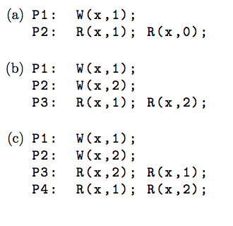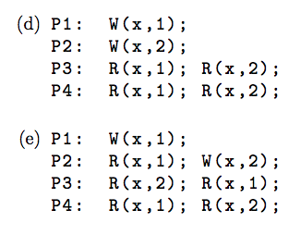

1. is not sequentially consistent because the effective sequence would have to be W(x, 1); R(x,1); R(x,0); which would not happen because x would not be read as 0 after having been written as 1.
2. is sequentially consistent because the effective sequence would be W(x,1); R(x,1); W(x,2);R(x,2); which makes perfect sense.
3. is not sequentially consistent because P3 and P4 have opposite read results, which can’t be sequentially consistent.
4. is sequentially consistent because the effective sequence would be W(x,1); R(x,1); R(x,1); W(x,2); R(x,2); R(x,2); which is completely acceptable because each process sees an operation on the same variable in the same order.
5. is not sequentially consistent for the same reason as (c).

**5. For each of the above executions, determine if the execution demonstrates causal consistency, assuming that we have monotonic reads.**

(a) is not causally consistent because we know on P2 that R(x,1) happens-before R(x,0) and therefore it is impossible without a rewriting of x to 0 for P2 to read x as 0.

(b) is causally consistent. We see a happens-before relationship on P3 and the other write actions on P1 and P2 do not conflict with this relationship.

(c) is causally consistent. We see a happens before in P3 and P4 and although they are opposites of one another, not all operations have to happen in the same order for it to be causally consistent. So P3 could receive notice of W(x,2) from P2 and then W(x,1) from P1 and P4 could receive those notices in the opposite order.

(d) is causally consistent for the same reason as (c) but it is simpler because P3 and P4 seem to be reading the writes in the same order.

(e) is not causally consistent because the happens-before relationship described in P2 (that R(x,1) happens before W(x,2)) suggests that W(x,1) occurs before P2s actions. This would mean that P3 would be unable to R(x,2) before R(x,1).